Basic concept： 1

Characters 1

Bomb 2

Map 3

UI： 3

## Basic concept：

**Target audience:** Players who like party games

**Gamer type:** Casual gamers

**Target platform:** Windows

**Number of players:** 2~4

Players control characters to kick the bomb. After the bomb being instantiated for several seconds, it will explode. When it explodes, player who stays closest to the bomb will receive most damage. When there is only one player left, the game ends.

## Characters

Appearance: Capsule with legs.

**Movement:**

Use unity standard assets – characters – ThirdPersonCharacter – Prefabs - ThirdPersonController

**Skills:**

Shift: Rush x distance toward the direction player is facing

CD： 2秒

**Die:**

Player will disappear when he dies. Instantiate a skull at the place he died. The skull has not collider.

## Bomb

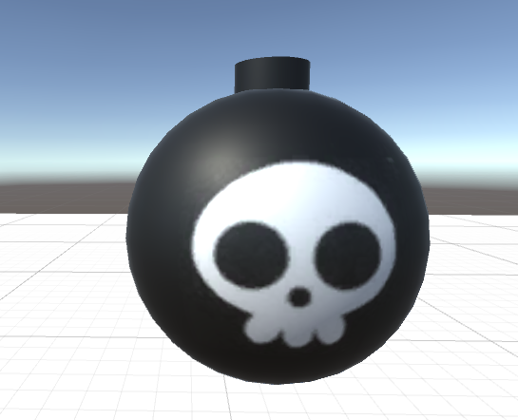

**Born position:**

Random. Be careful that it should not born at the players’ position.

**Explode time:**

5 seconds.

**Explode damage:**

For now, 1 damage for every players. (We will change the formula about its damage later.)

**Animation:**

Black and red change from each other, the closer the bomb is going to explode, the color changes faster.

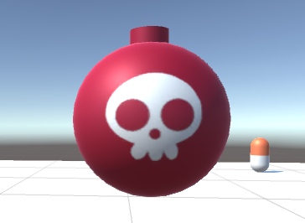

## Map

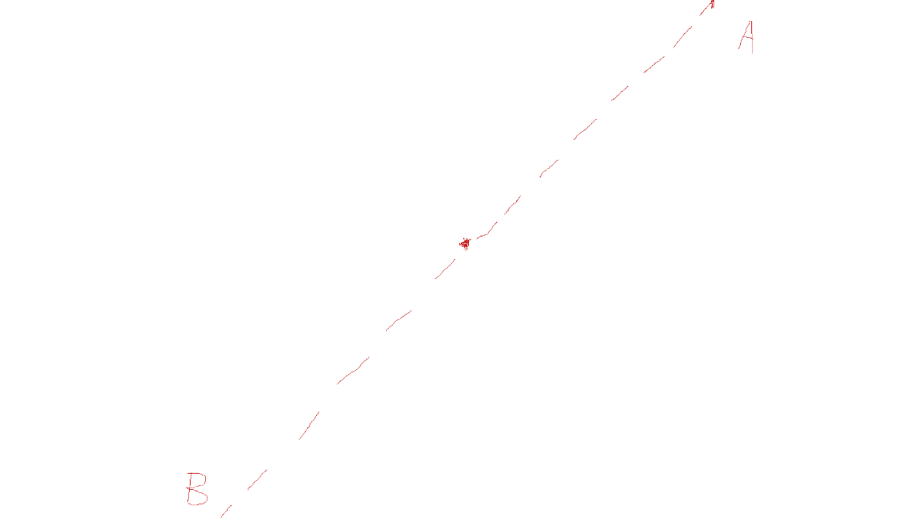

When the ball is going out of the screen from point A, it will appear at point B. Its speed, direction and explosion time will all remain the same. The only thing changes is its coordination.

When characters reach the border of the map, they cannot transform like the bomb, they will be stopped instead.

## UI：

When the game is opened, there will be 3 options:

Start

Settings

Exit

**HP:**

HP should follow the players and stand at the right side of players.

70% - 100%: Green

30% - 69%: Orange

0% - 29%: Red